Muhammad Adil Farooq
L1F24BSCS0135
Github = adil-warraich
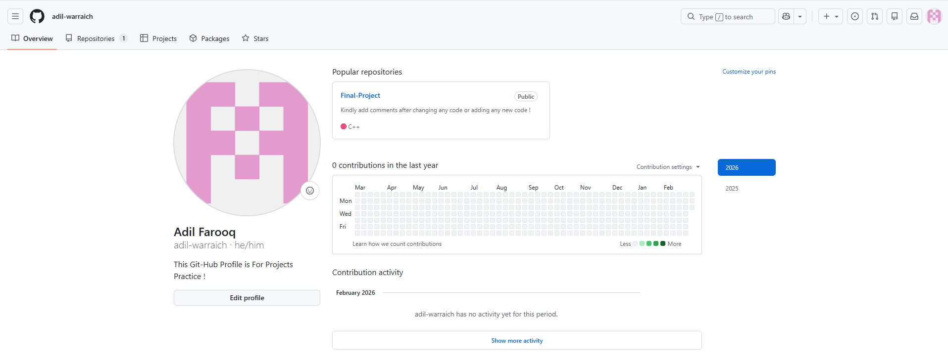

Task-1

Code:-
#include <iostream>
#include <string>
using namespace std;

template <typename T, size_t N>
void printArray(T(&arr)[N]) {
for (size_t i = 0; i < N; i++) {
cout << arr[i] << " ";
}
cout << endl;
}

template <typename T, size_t N>
void selectionSort(T(&A)[N]) {
for (size_t I = 0; I < N - 1; I++) {
size_t SmallSub = I;

for (size_t J = I + 1; J < N; J++) {
if (A[J] < A[SmallSub]) {
SmallSub = J;
}
}

if (SmallSub != I) {
T temp = A[I];
A[I] = A[SmallSub];
A[SmallSub] = temp;
}
}
}

int main() {

int intArray[5] = { 98, 10, 25, 22, 1 };
cout << "Original integer array: ";
printArray(intArray);

selectionSort(intArray);

cout << "Sorted integer array: ";
printArray(intArray);

string stringArray[4] = { "apple", "orange", "banana", "grape" };
cout << "\nOriginal string array: ";
printArray(stringArray);

selectionSort(stringArray);

cout << "Sorted string array: ";
printArray(stringArray);

return 0;
}
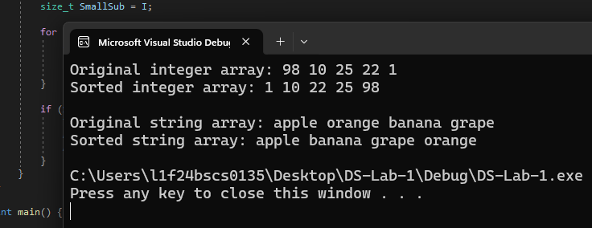

Task-2

Code:-

#include <iostream>
#include <string>
using namespace std;

template <typename T, size_t N>
int linearSearch(T(&A)[N], T Value) {
for (size_t I = 0; I < N; I++) {
if (A[I] == Value) {
return I;
}
}
return -1;
}

template <typename T>
void printSearchResult(int index, T key) {
if (index != -1) {
cout << "Value " << key << " found at index " << index << endl;
}
else {
cout << "Value " << key << " not found in the array." << endl;
}
}

int main() {

int intArray[5] = { 64, 25, 1, 22, 12 };
int intKey = 12;
int intIndex = linearSearch(intArray, intKey);
printSearchResult(intIndex, intKey);

float floatArray[4] = { 3.14, 2.71, 1.62, 0.57 };
float floatKey = 2.71;
int floatIndex = linearSearch(floatArray, floatKey);
printSearchResult(floatIndex, floatKey);

string stringArray[4] = { "apple", "orange", "guava", "grape" };
string stringKey = "apple";
int stringIndex = linearSearch(stringArray, stringKey);
printSearchResult(stringIndex, stringKey);

return 0;
}

